PSA Assignment 4 – Parallel Sorting  
  
Name: Yash Pravin Pawar  
Nu Id: 002747371  
Email: [pawar.ya@northeastern.edu](mailto:pawar.ya@northeastern.edu)Github : github.com/NeuYash/PSAAssignments  
Device: 2022 Macbook Pro M1 Max 16 gb RAM 512 gb ROM  
  
  
Code Snippets:   
  
Main.java  
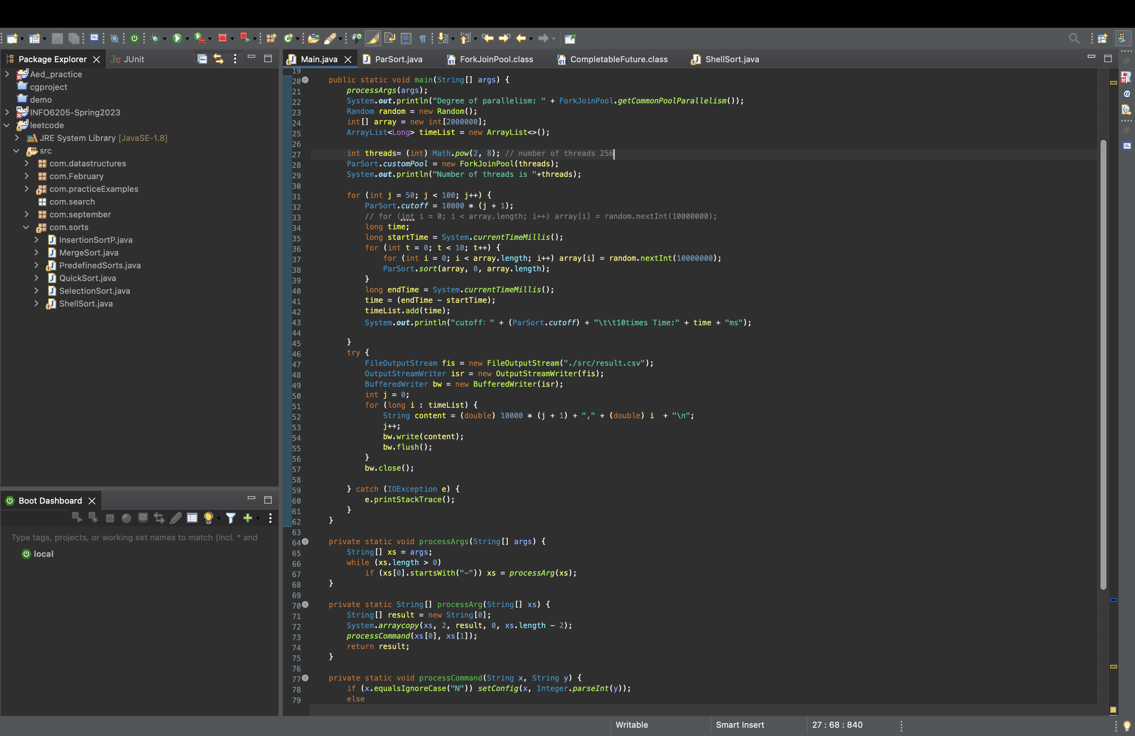

ParSort.java  
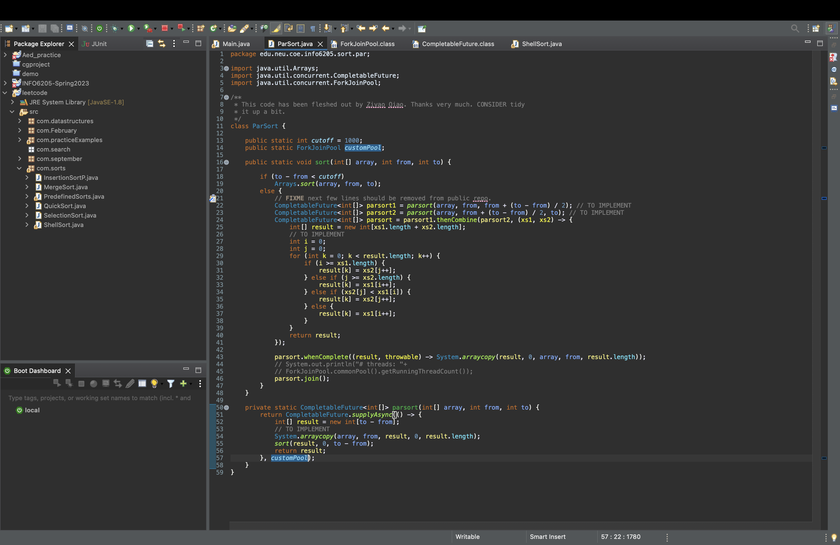

Conclusion:  
Below is the sheet embedded for the experiments performed.

The results of the trials show that the cutoff value and the quantity of threads affect sorting performance. The best sorting method for larger arrays is parallel sorting, which makes use of all available resources. Performance improves as we employ additional threads to carry out the sorting.

The system sort function seems to be a more effective way to sort the array once the cutoff value is achieved. According to the results of the experiment, it is preferable to increase the number of threads in order to improve performance if the cutoff value is greater, such as 1000000. However, since the cutoff is higher in this case, it is more likely that we are using system sort rather than parallel sort. However, when the array size grows and the cutoff stays the same, it becomes clear that using parallel sort with a larger number of threads—in this case, 256—helps to boost sorting efficiency.